Groin or sentinel lymph node surgery for patients
with vulval cancer

This information sheet has been written to answer some of your questions about removal of the lymph nodes in your groin or your sentinel lymph node. You have been given this leaflet because you have a vulval cancer which is greater than 1mm deep. Please take your time to read the following information carefully.

What is the surgery and why is it necessary?
The aim of this surgery is to reduce the risk of your vulval cancer spreading. In about one out of four cases, cancer of the vulva can spread through the lymph nodes, but it is unlikely to spread to lots of lymph nodes. Nodes are part of the immune system, distributed widely throughout the body and linked by lymphatic vessels. In vulval cancer the cancer is likely to spread to just one or two nodes first, before moving on to affect others. These first nodes are called the ‘sentinel nodes’. Your consultant will tell you which type surgery is most suitable for you; the standard treatment where all your groin nodes will be removed or the alternative treatment where only the sentinel nodes are removed.

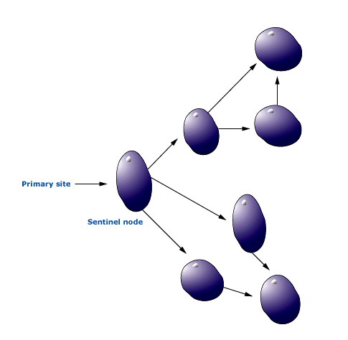
Other nodes
Sentinel Node

Consenting to treatment
We will ask you to sign a consent form agreeing to accept the treatment that you are being offered. The basis of the agreement is that you have had The Christie’s written description of the proposed treatment and that you have been given an opportunity to discuss any concerns. You are entitled to request a second opinion from another doctor who specialises in treating this cancer. You can ask your own consultant or your GP to refer you. Your consent may be withdrawn at any time before or during this treatment. Should you decide to withdraw your consent then a member of your treating team will discuss the possible consequences with you.

What is the standard treatment to remove all lymph nodes in groin?
Standard treatment is to remove all the lymph nodes in the groin, in case the cancer has spread. The benefit of having all of your nodes removed is that we can be certain whether the cancer has spread. This reduces the risk of your cancer returning. In some cases you may need further treatment in the form of radiotherapy. This will be discussed with you by your oncology team.

What are the risks of having all my groin lymph nodes removed?
Two out of three women having all their lymph glands removed will experience at least one of
the following complications:

- Lymphoedema – You may have swollen legs. If this persists longer than six to eight weeks you may need a referral to see the specialist lymphomoedema nurse.

- Lymphocyst formation – This is when lymph fluid collects in the groin causing swelling. You may require antibiotics and/or drainage of the lymphocyst.

- Infection or inflammation – May require antibiotics.

- Wound breakdown – May delay healing and mean that you might have to stay in hospital longer.

You will stay in hospital for one to two days, occasionally longer depending on your individual recovery, how you feel physically and emotionally and the support you have at home. This will be discussed with you before you have your operation and again while you are recovering.

Any complications may not happen immediately and may only occur once you have been discharged from hospital. Occasionally you may need to be readmitted to hospital for treatment for the complications.

What is the alternative treatment of removing only the sentinel nodes?
Recent studies have shown that if the sentinel node is clear of cancer then there is only a 3 in 100 chance of other lymph nodes being involved and there is little benefit in removing all of the nodes in the groin. In these cases, only the sentinel node is removed. This can also mean a smaller wound and shorter hospital stay. This reduces all of the complications associated with the standard treatment.

You will only be offered this option if:
- The vulval cancer is in one location.
- The cancer measures less than 4cm size.
- There are no enlarged lymph glands on examination or CT scan.

Identifying the sentinel node
An appointment will be made for you to attend the nuclear medicine department in the morning or afternoon before your surgery.

The technique to find the sentinel node involves injecting radioactive solution to the vulva before the surgery. A local anaesthetic cream will be applied to the vulva before this injection but
sometimes it can still be a little uncomfortable. Later the same day or the next morning you will have your operation. During your operation when you are asleep under general anaesthetic, blue dye will be injected to the vulva. Rarely, patients may have an allergic reaction to the dye (about one out of 200 women). Temporarily, the dye can discolour your skin and urine for a few days.
These two techniques (radioactive solution and dye) allow us to find the sentinel nodes in 19 out of 20 women. If we are unable to find the sentinel node this way, something that we will only know during the operation, then the only way to actually find out if there is any spread of cancer to the lymph nodes is to remove all the lymph nodes from that side of the groin.

What are the risks of having only my sentinel nodes removed?
There is a very small risk (about 2 out of 100 women) of the cancer spreading to other parts of the body.

Is there an option not to have groin or sentinel node surgery?
You have the option not to have surgery for your vulval cancer, however if you choose this option there is a chance that your cancer will spread. Without treatment the cancer can continue to spread and become advanced whereby surgery or radiotherapy can no longer be used as a curative treatment.

Whom should I contact for further information?
If you require additional information or advice, please contact your consultant’s secretary on the numbers below. They are available Monday-Friday. 8.00am – 4.00pm:

Mr Slade and Mr Winter-Roach 0161 446 3367
Mr Smith and Miss Myriokefalitaki 0161 446 8045

Alternatively if you want to speak to one of our Macmillan Clinical nurse specialists please call between 7.30am and 6.00pm:
0161 918 2186
0161 918 2183
0161 446 8235

If you need information in a different format, such as easy read, large print, BSL, braille, email, SMS text or other communication support, please tell your ward or clinic nurse.

We try to ensure that all our information given to patients is accurate, balanced and based on the most up-to-date scientific evidence. If you would like to have details about the sources used please contact patient.information@christie.nhs.uk

© 2017 The Christie NHS Foundation Trust. This document may be copied for use within the NHS only on the condition that The Christie NHS Foundation Trust is acknowledged as the creator.

For more information about The Christie and our services, please visit www.christie.nhs.uk or visit the cancer information centres at Withington, Oldham or Salford.

Contact The Christie Hotline for
urgent support and specialist advice

The Christie Hotline:
0161 446 3658

Open 24 hours a day, 7 days a week

The Christie NHS Foundation Trust
Wilmslow Road
Withington
Manchester M20 4BX
Tel: 0161 446 3000
www.christie.nhs.uk

The Christie Patient Information Service
March 2017 - Review March 2020

CHR/SUR/1182/25.01.17 Version 1

